Internet Programming **Assignment:1**

Answer:1) Physical method of Topology

Star topology: All the devices are connected to a single hub through a cable. This hub is the central node and all other nodes are connected to the central node. The hub can be passive in nature i.e., not an intelligent hub such as broadcasting devices, at the same time the hub can be intelligent known as an active hub.

Server

**Advantages of this topology :**

* If N devices are connected to each other in a star topology, then the number of cables required to connect them is N. So, it is easy to set up.
* Each device requires only 1 port i.e. to connect to the hub, therefore the total number of ports required is N.

## Bus Topology :

Bus topology is a network type in which every computer and network device is connected to a single cable. It transmits the data from one end to another in a single direction. No bi-directional feature is in bus topology. It is a multi-point connection and a non-robust topology because if the backbone fails the topology crashes.

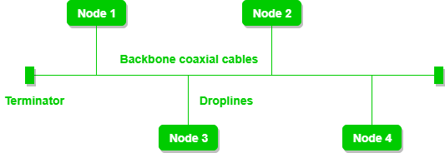

Server System

Node5

**Here , Node represent clients**

**Advantages of this topology :**

* If N devices are connected to each other in a bus topology, then the number of cables required to connect them is 1, which is known as backbone cable, and N drop lines are required.
* The cost of the cable is less as compared to other topologies, but it is used to build small networks.

**Answer:2)** a)  **It is the protocol that allows web servers and browsers to exchange data over the web** .

**b) It is a request response protocol.**

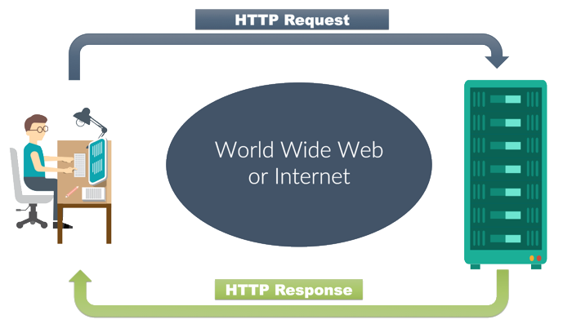

**Answer:3) In client server architetecture mainly three things reqire one in client (host or browser) , DNS server and Web server.**

**Step :1) when clients send request to server by the use of URL it goes to DNS server.**

**Step :2 ) DNS server responsd the clients by converting URL into IP address.**

**Step:3) By the help of its IP address client browser send request to web server(makes http request to IP) .**

**Step:4) After that web server respond to its request and send that and information that they want(http respond with data files).**

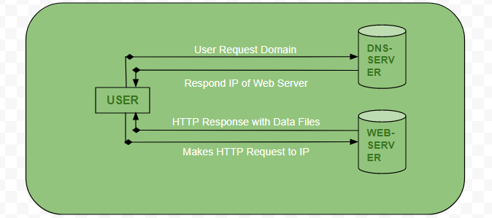

**Answer:4) ceo.htm**

**Answer :5) <head>**

**<TITLE>answer 5</title>**

**</head>**

**<body>**

**&lt;html&gt;<br>**

**&lt;head&gt;<br>**

**&lt;title&gt;<br>**

**&lt;&sol;titlegt;<br>**

**&lt;&sol;head&gt;<br>**

**&lt;body&gt;<br>**

**Content of web page should be displayed<br>**

**&lt;&sol;body;&gt;<br>**

**&lt;&sol;html&gt;<br>**

**</body>**

**</html>**